**TOUR TROVE**

**Submitted in partial fulfillment of the requirements for the award of the Degree**

***of***

**Bachelor of Technology (B. Tech)**

**in**

**INFORMATION TECHNOLOGY**

**By**

M. Nishanth - 22AG1A1236

P. Uha Aravind Sai - 22AG1A1249

M. Dhanraj - 22AG1A1237

**Under the esteemed Guidance of**

Mr. S. Venu Gopal

Assistant Professor



**Department of Information Technology**

**ACE ENGINEERING COLLEGE**

**An Autonomous Institution**

All the courses are Accredited by NBA and NAAC with A Grade

**(Affiliated to Jawaharlal Nehru Technological University, Hyderabad, Telangana)**

Ankushapur, Ghatkesar, Medchal, Hyderabad – 501 301

ACE

**Engineering College**

**An Autonomous Institution**

**All the courses are Accredited by NBA and NAAC with A Grade**

**(Affiliated to Jawaharlal Nehru Technological University, Hyderabad, Telangana)**

**Website: www.aceec.ac.in E-mail: info@aceec.ac.in**This e-mail address is being protected from spambots, you need JavaScript enabled to view it

### CERTIFICATE

This is to certify that the Real-Time Project work entitled **“TOUR TROVE”** is being submitted by **M.NISHANTH (22AG1A1236), P.UHA ARAVIND SAI (22AG1A1249),** **M.DHANRAJ(22AG1A1237**) impartial fulfilment for the award of Degree of BACHELOR OF TECHNOLOGY in INFORMATION TECHNOLOGY to the Jawaharlal Nehru Technological University, Hyderabad during the academic year 2023-24 is a record of Bonafide work carried out by him/her under our guidance and supervision.

The results embodied in this report have not been submitted by the student to any

other University or Institution for the award of any degree or diploma.

**Internal Guide Head of the Department**

**Mr. S. Venu Gopal Prof. K. JAYA BHARATHI**

**Assistant professor Professor and Head Dept. of IT**

**EXTERNAL EXAMINER**

# ACKNOWLEDGEMENT

We would like to express our gratitude to all the people behind the screen who have helped us to transform an idea into a real time application.

We would like to express our heart-felt gratitude to our parents without whom we would not have been privileged to achieve and fulfil our dreams.

A special thanks to our Secretary, **Prof. Y. V. GOPALA KRISHNA MURTHY** and Joint Secretary, **Mrs.M.PADMAVATHI** for having founded such an esteemed institution. We are also grateful to our beloved principal, **Dr. B. L. RAJU** for permitting us to carry out this project.

We profoundly thank **Prof. K. JAYA BHARATHI**, Head of the Department of Information Technology, who has been an excellent guide and a great source of inspiration to our work.

We are very thankful to our internal guide **G. Prasad**, who has been an excellent and given continuous support for the completion of our project work.

The satisfaction and euphoria that accompany the successful completion of the task would be great, but incomplete without the mention of the people who made it possible, whose guidance and encouragement crown all the efforts with success. In this context, we would like to thank all the other staff members, teaching and non- teaching, who have extended their timely help and eased our task.

**M. NISHANTH (22AG1A1236) P.UHA ARAVIND SAI (22AG1A1249)**

**M.DHANRAJ (22AG1A1237)**

# DECLARATION

We hereby declare that the project entitled “**TOUR TROVE**” submitted in partial fulfilment of the requirements for the award of degree of Bachelor of Technology in Information Technology. This dissertation is our original work and the project has not formed the basis for the award of any degree, associate ship, fellowship or any other similar titles and no part of it has been published or sent for the publication at the time of submission.

**M. NISHANTH (22AG1A1236)**

**P.UHA ARAVIND SAI (22AG1A1249)**

**M.DHANRAJ (22AG1A1237**

# ABSTRACT

**TOUR TROVE**

# Tour Trove revolutionizes travel planning by simplifying options based on your preferences and budget, setting itself apart from overwhelming travel platforms. Utilizing advanced algorithms, it offers personalized recommendations that surpass those of other apps. By analyzing user reviews for sentiment and integrating expert insights, Tour Trove ensures a balanced perspective. The platform provides transparent cost details, real-time pricing updates, and a dependable infrastructure for booking flights, accommodations, and activities seamlessly. Tour Trove sets new standards in convenience, personalization, and trust for global travelers, aiming to enhance the travel experience through simplified decision-making and elevated user satisfaction.

# Moreover, Tour Trove's intuitive interface and robust search capabilities make discovering new destinations a breeze. The platform's interactive maps and virtual tours allow users to explore potential travel spots before committing. With features such as customizable itineraries and a comprehensive travel planner, Tour Trove ensures that every aspect of your journey is tailored to your needs. Coupled with 24/7 customer support and secure payment options, Tour Trove truly redefines the travel planning process, making it not only easier but also more enjoyable. Experience the future of travel with Tour Trove, where your dream vacation is just a few clicks away.

# INDEX

**CONTENTS Page No.**

**List Of Figures** viii

**List Of Abbreviations** ix

**CHAPTER 1: INTRODUCTION 1-2**

* 1. Overview 1
  2. Purpose 2
  3. Scope 2

**CHAPTER 2: LITERATURE SURVEY 3-5**

2.1 Existing System 4

2.2 Proposed System 5

**CHAPTER 3: SOFTWARE REQUIREMENT ANALYSIS 6-10**

3.1 Software Requirement Specification 6

3.1.1 Functional Requirements 6

3.1.2 Non-Functional Requirements 8

3.2 Software &Hardware Requirements 10

3.2.1 Hardware Requirements 10

3.2.2 Software Requirements 10

**CHAPTER 4: SOFTWARE DESIGN 11-19**

4.1 Introduction 12

4.2 Architecture 13

4.3 Dataflow Diagrams  **14-15**

**CHAPTER 5**: **Software &Hardware Requirements**

5.1 Hardware Requirements 10

5.2 Software Requirements

**CHAPTER 6: MODULES 20-21**

5.1 User Management Module 20

5.2 Booking Module 20

5.3 Recommendation Module 20

5.4 Admin Dashboard and Management Module 21

**CHAPTER 7: CODING TEMPLATES 22-31**

**CHAPTER 8: TESTING AND VALIDATION 32**

7.1 Software Testing 32

7.2 Test Case Design 32

**CHAPTER 9: OUTPUT SCREENS 33**

**CHAPTER 10: CONCLUSIONS 39**

**CHAPTER 11: FUTURE ENHANCEMENTS 40**

**CHAPTER 12: REFERENCES 41**

# LIST OF FIGURES

**List of Figures Page No.**

1. Architecture………………………………………………………………....13
2. DFD Level – 0……………………………………………………………...14
3. DFD Level – 1……………………………………………………………...15
4. DFD Level – 2……………………………………………………………...15
5. Sequence Diagram ……….………………………………………………...16
6. Activity Diagram ……….………………………………………………….17
7. Use Case Diagram……….…………………………………………………19
8. Class Diagram………………………………………………………………19
9. Deployment Diagram……………………………………………….….…...16
10. Login Page……………………………………………………………….….33
11. Registration Page……………………………………………………………33
12. Dash Board Page 1 ………………………………………………………....34
13. User – Post Page 2 ………………………………………………………….34
14. Create Exam page……………………………………………………………35
15. Start Exam page……………………………….……….…………………….35
16. Alert page 1….………………………………………………………………36
17. Alert page 2.………….……………………………………………………...36
18. Alert page 3…….……………………………………………………………37
19. Test Submitted……………..………………………………………………..37
20. Cheating Log Page…………………………………………………………..38

# CHAPTER 1

## INTRODUCTION

## 

### Tour Trove is a modern travel platform designed to simplify trip planning and enhance enjoyment. Our easy-to-use tools save valuable time, allowing you to effortlessly organize every aspect of your journey. By connecting travelers, Tour Trove fosters a community where shared insights enrich every adventure. Explore countless destinations and services worldwide tailored to fit everyone's travel preferences. With a constantly updated database, you'll always have access to the latest information on places to see, stay, and play, ensuring your trips are consistently exceptional and memorable. Tour Trove goes beyond mere itinerary management; it's a gateway to immersive travel experiences. Our platform empowers you to discover hidden gems and local favorites, ensuring each trip is unique and authentic. Whether you're seeking adventure, relaxation, or cultural exploration, Tour Trove offers curated recommendations that align with your interests. Join a community of like-minded travelers to share tips, stories, and insider knowledge, enriching your journey with valuable insights. With a user-friendly interface and robust features, Tour Trove is your ultimate companion for seamless travel planning and unforgettable experiences around the globe. Start your next adventure with Tour Trove and unlock a world of possibilities.

### 1.1 Overview:

Tour Trove revolutionizes travel planning by simplifying options based on user preferences and budgets, distinguishing itself from other platforms. It employs advanced algorithms to offer personalized recommendations, combining sentiment analysis of user reviews with expert insights for balanced perspectives. The platform provides transparent cost details, real-time pricing updates, and a reliable booking infrastructure, ensuring a seamless experience for flights, accommodations, and activities.

### 1.2 Purpose:

The purpose of this project is to develop a sophisticated machine learning-based system for accurately predicting house prices. This system is designed to serve multiple stakeholders, including homeowners, real estate investors, policymakers, and urban planners, by providing them with reliable and actionable insights into the housing market. key purpose of this project is Enhancing Decision-Making, Supporting Policymaking and Urban Planning, Advancing Technological Integration.

By fulfilling these purposes, this project aims to not only improve the accuracy of house price predictions but also to empower various stakeholders with the tools and insights needed to navigate the complex landscape of the real estate market effectively.

### 1.3 Scope:

The scope of this project encompasses the comprehensive development and deployment of a machine learning-based house price prediction system. This project covers various aspects, from data collection to model deployment, ensuring a robust and user-friendly tool for stakeholders. The detailed scope includes data collecting and management, data preprocessing, deployment, Model Evaluation and Validation, Scalability and Maintenance.

By encompassing these aspects, the scope of this project ensures a holistic approach to house price prediction, delivering a reliable and efficient tool for various stakeholders in the real estate market.

**CHAPTER 2**

## LITERATURE SURVEY

* **www.expedia.com**

Author: Rich Barton, Lloyd Frink

Publisher: Expedia Group

Technology: Various (HTML, CSS, JavaScript, Node.js, Python)

Summary: This platform offers a wide range of travel options, including flights, hotels, and car rentals. However, it often overwhelms users with too many choices, leading to decision fatigue. Additionally, the recommendation system may not always be personalized, and customer support can be slow to respond, especially during peak travel times.

* **www.booking.com**

**Author: Geert-Jan Bruinsma**

**Publisher: Booking Holdings Inc.**

**Technology: HTML, CSS, JavaScript, Java**

**Summary: Known for its extensive inventory of accommodations, Booking.com sometimes provides inconsistent pricing details, which can confuse users. The user interface is also cluttered, making navigation difficult. Although they offer 24/7 customer support, response times can vary, and resolving issues can be challenging.**

* **www.tripadvisor.com**

Author: Stephen Kaufer, Langley Steinert

Publisher: TripAdvisor LLC

Technology: HTML, CSS, JavaScript, PHP

Summary: TripAdvisor excels in user-generated reviews and recommendations but often falls short in providing real-time pricing updates. The platform's search and filter functions can be less intuitive, causing frustration. Customer support is available, but users frequently report slow and ineffective responses.

TITLE :- A Smart Tourism Platform

PUBLISHER NAMES :- Dimas Apriyandi

PUBLISHED YEAR :- 2024

TITLE :- Virtual Tourist Communities and Online

Travel Communities

PUBLISHER NAMES :- Marina-Magdalena ,Eva Sanchez,Oscar junanatey

PUBLISHED YEAR :- 2020

#### **EXISTING SYSTEM**

### Many current tourism websites, such as Expedia, Booking.com, and TripAdvisor, are built using a variety of sophisticated technologies, including HTML, CSS, JavaScript, and robust back-end frameworks like node.js, Ruby on Rails, and Django. These platforms leverage expansive databases and cloud computing services to manage vast amounts of user data efficiently, providing real-time updates and seamless user experiences. Advanced algorithms are employed to deliver tailored recommendations, while APIs facilitate seamless integration with numerous third-party services, encompassing airlines, hotels, and car rental companies.

### Furthermore, there is a growing emphasis on sustainability and ethical considerations within these platforms. Many are integrating features that highlight eco-friendly accommodations and activities, catering to the increasing demand for responsible travel options. Innovations in virtual reality and augmented reality are also being explored to enhance the pre-booking experience, allowing users to virtually explore destinations and accommodations before making a decision. Collaborations with local communities and cultural organizations are fostering authentic travel experiences that go beyond traditional tourist attractions. As these technologies evolve, the focus remains on enriching the travel journey while addressing the diverse needs and expectations of global travelers in a dynamic and competitive marketplace.

### Furthermore, the integration of social media functionalities and user-generated content is enriching the booking experience, allowing travelers to share insights and recommendations directly within the platform. These collaborative features enhance engagement and community building among users, fostering a more interactive and connected travel community globally.

### LIMITATIONS:

Here are the side headings for the limitations of current tourism websites:

1. Information Overload

2. Pricing Transparency

3. Customer Support Variability

4. Privacy and Security Concerns

5. User Interface Complexity

6. Reliability of Recommendations

* 1. **PROPOSED SYSTEM**

Real-time monitoring and alerts form the backbone of the Astro Econ Adventure platform, ensuring proactive management of all travel-related activities to enhance user experience. The system utilizes sophisticated monitoring tools that continuously track critical metrics such as flight statuses, accommodation availability, and itinerary changes. By integrating real-time data streams and automated alerts, users receive prompt notifications about updates or disruptions, allowing them to swiftly adjust their travel plans. This proactive approach not only enhances convenience but also minimizes potential disruptions, ensuring a seamless and stress-free travel experience for all platform users.

In addition to real-time monitoring, Astro Econ Adventure employs machine learning algorithms to predict potential issues based on historical data and current trends. This predictive capability enables the platform to intervene proactively, further enhancing the reliability of travel arrangements. Users benefit from customizable alert preferences, receiving notifications through preferred channels such as email, SMS, or in-app messages. This personalized alert system ensures that travelers receive pertinent information tailored to their specific needs and preferences. Furthermore, the platform offers real-time weather updates and notifications about local events, enabling users to stay informed about conditions that could impact their travel plans.

Furthermore, **TOUR TROVE** integrates these predictive capabilities seamlessly into its user interface, providing travelers with proactive insights and recommendations. By analyzing patterns in travel data, the platform not only anticipates potential disruptions but also suggests alternative routes or accommodations to optimize travel plans. This proactive approach not only enhances the reliability of travel arrangements but also empowers users to make informed decisions swiftly. With continuous updates and personalized alerts, Astro Econ Adventure ensures that every journey is as smooth and stress-free as possible, reaffirming its commitment to delivering a superior travel management experience.

**ADVANTAGES:**

* + - * 1. Proactive Issue Prediction
      * 2. Customizable Alert Preferences
      * 3. Comprehensive Real-Time Updates

# CHAPTER 3

**SOFTWARE REQUIREMENT ANALYSIS**

## SOFTWARE REQUIREMENT SPECIFICATIONS (SRS)

## Functional requirements

**Real-time Monitoring:** The system should continuously monitor website traffic and content in real-time.

**Harmful Content Detection:** Identify and flag websites containing harmful content such as phishing, malware, or inappropriate material..

**Scalability:** The solution should be scalable to handle varying levels of web traffic and content volume effectively.

**Notification System:** Implement a notification mechanism to alert administrators or users when a harmful website is detected.

**Reporting:** Generate comprehensive reports on detected threats, trends in website activity, and effectiveness of detection algorithms.

**Compliance:** Ensure compliance with relevant data protection and privacy regulations during data collection and processing.

**Accuracy:** Ensure high accuracy in detecting harmful websites to minimize false positives and negatives.

**3.1.2 Non-functional requirements**

**Performance:** The system should exhibit low latency in detecting harmful websites, ensuring minimal impact on user browsing speed**.**

**Reliability:** Ensure high availability and reliability of the detection system, with minimal downtime or service interruptions.

**Scalability**: The solution should scale seamlessly to accommodate increasing web traffic and content volume without compromising performance.

**Security:** Implement robust security measures to protect the system from cyber threats and unauthorized access

**Usability**: The user interface should be intuitive and user-friendly for administrators to manage and monitor detected threats effectively**.**

**Maintainability:** The system should be easy to maintain and update, with clear documentation and modular components for efficient troubleshooting and enhancements.

**Compliance:** Ensure compliance with industry standards and regulatory requirements concerning data privacy and cybersecurity**.**

# CHAPTER 4

# SOFTWARE DESIGN

### 4.1 INTRODUCTION

In today's digital landscape, ensuring safe and secure browsing experiences is paramount. The project aims to develop a robust system for real-time detection of harmful websites, such as those hosting phishing schemes, malware, or inappropriate content. By leveraging advanced algorithms and continuous monitoring, the system will proactively identify and mitigate risks to user security and privacy. Emphasizing compliance with stringent data privacy and cybersecurity standards, the project seeks to provide users with a reliable tool that enhances online safety and trust worthiness

### 4.2 ARCHITECTURE

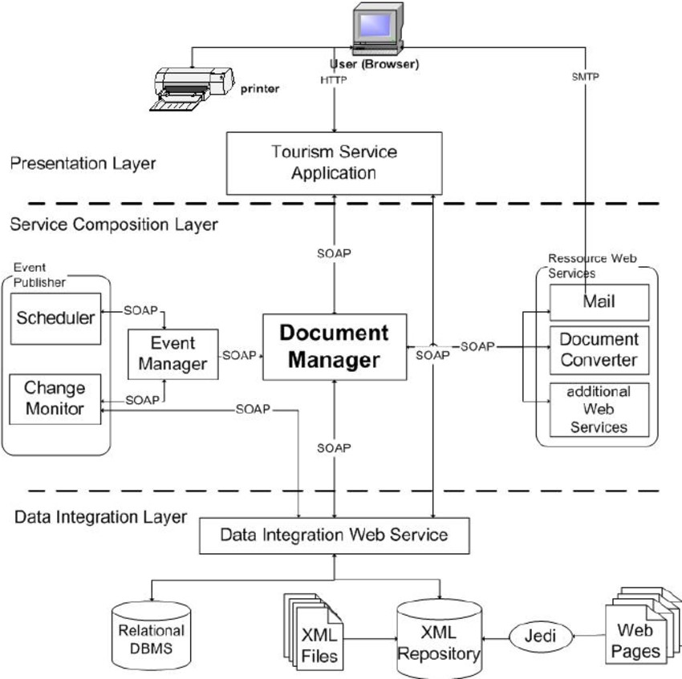

Fig: 4.1 Architecture

### 4.3 DATA FLOW DIAGRAM

DFD is a visual representation of the flow of data within a system, showing how data is transformed and moved from one process or entity to another. A DFD consists of a set of symbols and connectors that represent the various processes, entities, and data flows in the system. The symbols are used to represent different types of elements in the system, such as processes, data stores, and external entities and the connectors are used to show the flow of data between these elements. DFDs are used to model and design systems, as well as to document and communicate the structure and behavior of existing systems. They can be used to identify and analyze the data flows within a system, as well as to identify potential bottlenecks or other issues that may need to be addressed.

**4.3.1 DFD diagram**

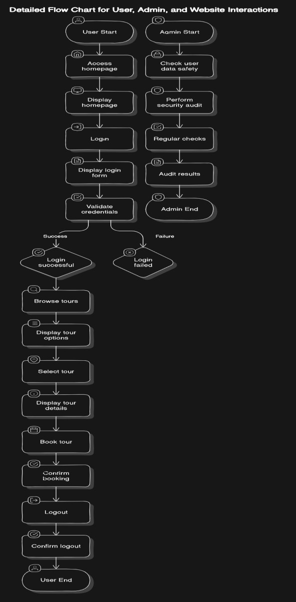

Fig: 4.2 data flow diagram

# CHAPTER 6

**MODULES**

6.1 **User Management Module:**

* Handles user registration, login, and profile management.
* Manages user preferences and personal information.
* Includes authentication and authorization functionalities to ensure secure access.

6.2 **Booking and Reservation Module:**

* Facilitates search, selection, and booking of flights, accommodations, and activities.
* Manages reservations and cancellations.
* Integrates with payment gateways for secure transactions.

6.3 **Recommendation and Personalization Module:**

* Provides personalized recommendations based on user preferences, past bookings, and behaviour.
* Utilizes algorithms to suggest destinations, accommodations, and activities.
* Allows for customization of travel itineraries based on user inputs.

6.4 **Admin Dashboard and Management Module:**

* Provides administrators with a dashboard to manage users, bookings, and content.
* Includes analytics and reporting tools for monitoring performance and trends.
* Facilitates content management and updates for destinations, travel options, and promotions.

# CHAPTER 7

**CODING TEMPLATES**

**7.1**

<!DOCTYPE html>

<html lang="en">

<head>

    <meta charset="UTF-8">

    <meta name="viewport" content="width=device-width, initial-scale=1.0">

    <title>Reservation Form</title>

    <style>

        body, html {

            margin: 0;

            padding: 0;

            height: 100%;

            display: flex;

            justify-content: center;

            align-items: center;

            /* background: url('new.jpg') no-repeat center center fixed; */

            background-size: cover;

            font-family: Arial, sans-serif;

        }

        .reservation-form {

            background: rgba(0, 0, 0, 0.7);

            padding: 20px;

            border-radius: 10px;

            color: #fff;

            max-width: 400px;

            width: 100%;

            text-align: center;

        }

        .reservation-form input, .reservation-form select {

            width: calc(100% - 20px); /* Adjust width to account for padding */

            padding: 10px;

            margin: 10px 10px 10px 0; /* Ensure spacing on the right */

            border: none;

            border-radius: 5px;

            background: rgba(255, 255, 255, 0.3);

            color: #fff;

        }

        .reservation-form input[type="submit"] {

            background: #ff6600;

            color: #fff;

            font-size: 16px;

            cursor: pointer;

            transition: background 0.3s;

            margin-top: 20px; /* Ensure submit button has top margin */

        }

        .reservation-form input[type="submit"]:hover {

            background: #ff4500;

        }

        .reservation-form h2 {

            margin-bottom: 20px;

        }

        .flex-container {

            display: flex;

            justify-content: space-between;

        }

        .flex-item {

            width: calc(33.33% - 10px); /* Adjust width to account for spacing */

        }

        /* Ensure options are visible */

        select option {

            color: #000;

        }

    </style>

</head>

<body>

    <div class="reservation-form">

        <h2>Make Your Reservation</h2>

        <form id="reservationForm">

            <input type="text" name="location" placeholder="Country, ZIP, city..." required>

            <div class="flex-container">

                <input class="flex-item" type="date" name="checkin" placeholder="Check In" required>

                <input class="flex-item" type="date" name="checkout" placeholder="Check Out" required>

            </div>

            <div class="flex-container">

                <select class="flex-item" name="rooms" required>

                    <option value="" disabled selected>no of rooms</option>

                    <option value="1">1</option>

                    <option value="2">2</option>

                    <option value="3">3</option>

                    <option value="4">4</option>

                    <option value="5">5</option>

                </select>

                <select class="flex-item" name="adults" required>

                    <option value="" disabled selected>no of adults</option>

                    <option value="1">1</option>

                    <option value="2">2</option>

                    <option value="3">3</option>

                    <option value="4">4</option>

                    <option value="5">5</option>

                </select>

                <select class="flex-item" name="children">

                    <option value="" disabled selected>no of children</option>

                    <option value="0">0</option>

                    <option value="1">1</option>

                    <option value="2">2</option>

                    <option value="3">3</option>

                    <option value="4">4</option>

                    <option value="5">5</option>

                </select>

            </div>

            <input type="email" name="email" placeholder="Enter your Email" required>

            <input type="tel" name="phone" placeholder="Enter your Phone" required>

            <input type="submit" value="BOOK NOW">

        </form>

    </div>

    <script>

        document.getElementById('reservationForm').addEventListener('submit', function(e) {

            e.preventDefault();

            alert('Reservation form submitted!');

        });

    </script>

</body>

</html>

## 

## CHAPTER 8

## TESTING AND VALIDATION

## 8.1 Functional Testing:

## Unit Testing: Testing individual components/modules to verify they perform as expected.

## Integration Testing: Testing interactions between different modules to ensure they work together correctly.

## System Testing: Testing the entire system to validate overall functionality, including user flows, booking processes, and administrative tasks

**8.2 Performance Testing:**

**Load Testing:** Assessing how the system performs under expected load conditions, such as peak booking times.

**Stress Testing:** Testing the system's ability to handle extreme load conditions beyond normal operational capacity.

**Response Time Testing:** Measuring response times for critical operations like booking confirmation and itinerary updates.

**8.3 Security Testing:**

**Vulnerability Assessment:** Identifying and addressing potential security vulnerabilities, such as SQL injection or cross-site scripting (XSS).

**Penetration Testing:** Simulating attacks to uncover weaknesses in the system's security defenses.

**Data Protection Testing:** Ensuring compliance with data protection regulations (e.g., GDPR, CCPA) and secure handling of user data.

**8.4 Usability Testing:**

* **User Interface Testing:** Evaluating the usability of the interface, including navigation, layout, and accessibility.
* **User Experience Testing:** Gathering feedback from users to assess overall satisfaction with the booking process and features.
* **A/B Testing:** Comparing different versions of the interface or features to determine which performs better in terms of user engagement and satisfaction.

**8.5 Validation:**

**User Acceptance Testing (UAT):** Conducting tests with actual users to validate that the system meets their requirements and expectations**.**

**Compliance Validation:** Ensuring the project adheres to industry standards, regulatory requirements, and internal policies**.**

**Performance Validation:** Confirming that the system performs adequately in real-world scenarios and meets performance metrics defined during testing.

### Documentation and Reporting:

### Documenting test cases, procedures, and results for future reference and troubleshooting.

### Generating reports on testing outcomes, including identified issues, their severity, and recommendations for resolution.

### Communicating findings and recommendations to stakeholders, developers, and project managers for further action and improvement.

### CHAPTER 9

**OUTPUT SCREENS OF THE PROJECT**

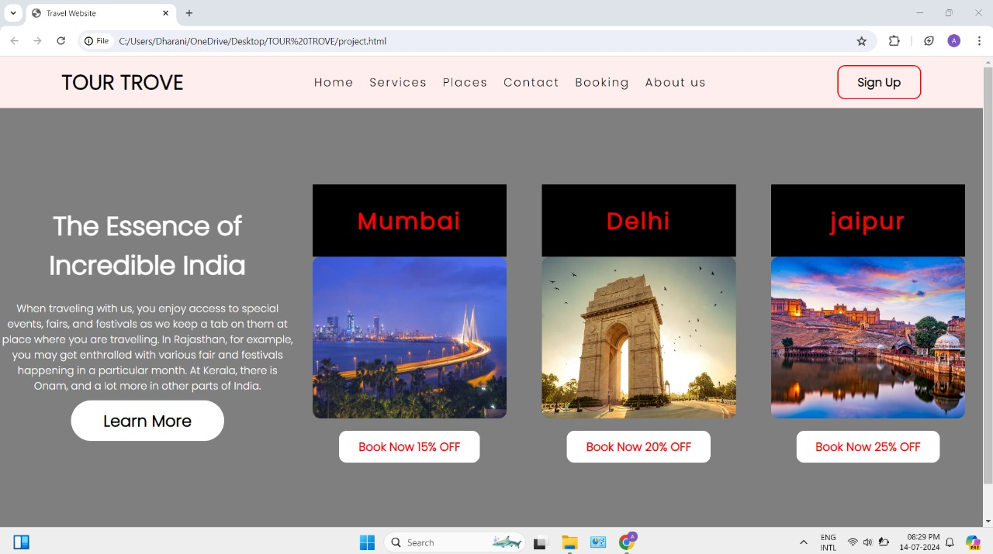

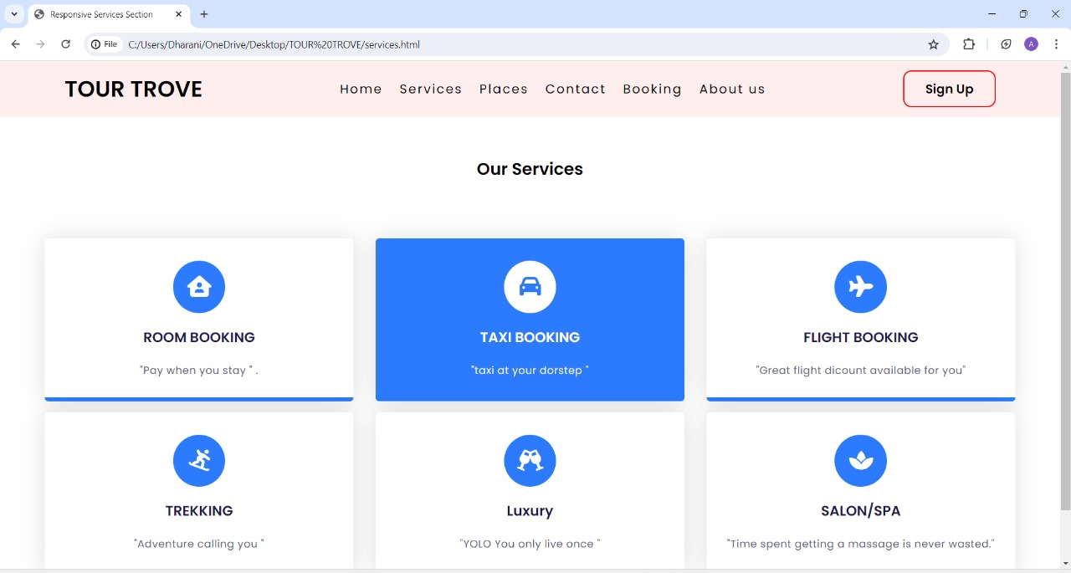

# 

# 

# CHAPTER 10

## CONCLUSION

# In conclusion, thorough testing and validation are essential to ensuring the success and reliability of our tourism project. By rigorously testing each module for functionality, performance, security, and usability, we can confidently deliver a system that meets the needs and expectations of users. From functional testing to validate booking and recommendation systems, to performance testing ensuring seamless operation under varying loads, and security testing to safeguard user data, every aspect is meticulously examined. Usability testing ensures a user-friendly interface, while validation through user acceptance testing and compliance checks guarantees adherence to industry standards and regulations.

# Ultimately, by prioritizing testing and validation throughout the development lifecycle, we not only mitigate risks but also enhance the overall quality and trustworthiness of our tourism platform. This approach ensures that travelers can confidently plan and book their journeys, knowing they are supported by a robust, secure, and user-centric system.

# CHAPTER 11

## FUTURE ENHANCEMENT

**Augmented Reality Integration**: Implement AR for virtual destination previews and immersive travel planning experiences.

**Blockchain for Transparent Transactions**: Introduce blockchain technology to ensure secure and transparent booking transactions.

**Predictive Analytics for Dynamic Pricing:** Utilize predictive analytics to offer dynamic pricing based on real-time demand and supply trends.

# CHAPTER 12

## REFERENCES

1. A. Zakary Azad and E. Duman, “A profit-driven Artificial Neural Network (ANN) with applications to fraud detection and direct marketing,” Neurocomputing, vol. 175, pp. 121– 131, Jan. 2016.
2. C. Jiang, J. Song, G. Liu, L. Zheng, and W. Luan, “Credit card fraud detection: A novel approach using aggregation strategy and feedback mechanism,” IEEE Internet of Things Journal, vol. 5, no. 5, pp. 3637–3647, 2018.
3. G. Liu, J. Tang, Y. Tian, and J. Wang, “Graph Neural Network for Credit Card Fraud Detection,” 2021 International Conference on Cyber-Physical Social Intelligence (ICCSI), pp. 1–6, 2021.
4. M. A. Sharma, B. G. Raj, B. Ramamurthy, and R. H. Bhaskar, “Credit Card Fraud Detection Using Deep Learning Based on Auto-Encoder,” ITM Web of Conferences, vol. 50, 2022.

R. B. Sulaiman, V. Schetinin, and P. Sant, “Review of machine learning approach on credit card fraud detection,” Human-Centric Intelligent Systems, vol. 2, no. 1-2, pp. 55– 68, 2022.